Bahria University,

Karachi Campus



COURSE: CSC-110 COMPUTING FUNDAMENTALS

TERM: FALL 2020, CLASS: BSE- 1 (A,B)

Submitted By:

M MUAZ SHAHZAD 02-131202-081

(Name) (Reg. No.)

Submitted To:

Dr. Salahuddin / Engr. Saniya Sarim

Signed Remarks: Score:

INDEX

|  |  |  |  |  |
| --- | --- | --- | --- | --- |
| SNO | DATE | LAB NO | LAB OBJECTIVE | SIGN |
| 01 | 03 Dec 2020 | 10 | **MS-Access - Tables, queries, reports and forms** |  |
|  |  |  |  |  |
|  |  |  |  |  |
|  |  |  |  |  |
|  |  |  |  |  |
|  |  |  |  |  |
|  |  |  |  |  |
|  |  |  |  |  |
|  |  |  |  |  |
|  |  |  |  |  |
|  |  |  |  |  |
|  |  |  |  |  |
|  |  |  |  |  |
|  |  |  |  |  |
| SNO | DATE | LAB NO | LAB OBJECTIVE | SIGN |
|  |  |  |  |  |
|  |  |  |  |  |
|  |  |  |  |  |
|  |  |  |  |  |
|  |  |  |  |  |
|  |  |  |  |  |
|  |  |  |  |  |
|  |  |  |  |  |
|  |  |  |  |  |
|  |  |  |  |  |
|  |  |  |  |  |
|  |  |  |  |  |
|  |  |  |  |  |
|  |  |  |  |  |
|  |  |  |  |  |

Bahria University,

Karachi Campus



LAB EXPERIMENT NO.

**10**

LIST OF TASKS

|  |  |
| --- | --- |
| TASK NO | OBJECTIVE |
| 1 | **Create a MS access database that contains these tables**   * Products * Customers * Sales * Employees   Generate report for sales, create forms for data entry in tables and filtering data. |
|  |  |
|  |  |
|  |  |
|  |  |
|  |  |
|  |  |

Submitted On:

Date:   
17/12/2020

**Task No. 1: Create a MS access database that contains these tables**

* **Products**
* **Customers**
* **Sales**
* **Employees**

**Generate report for sales, create forms for data entry in tables and filtering data.**

**Solution:**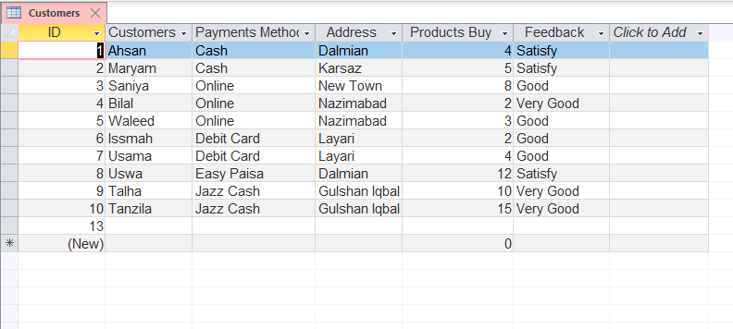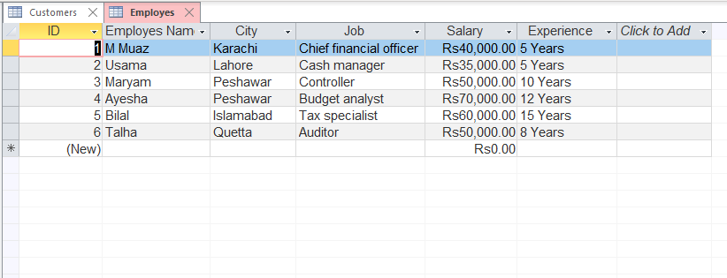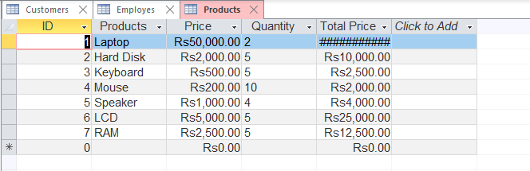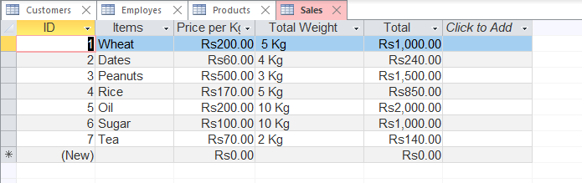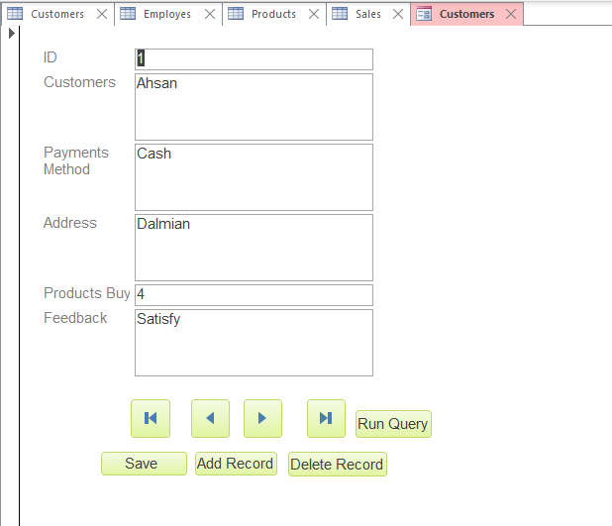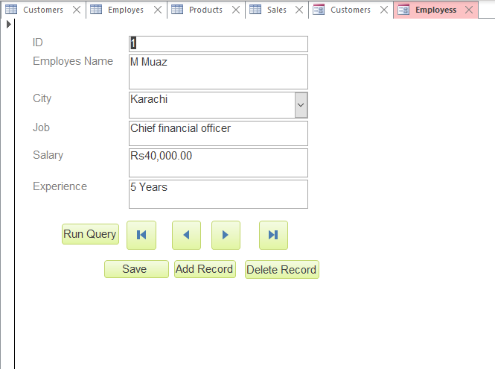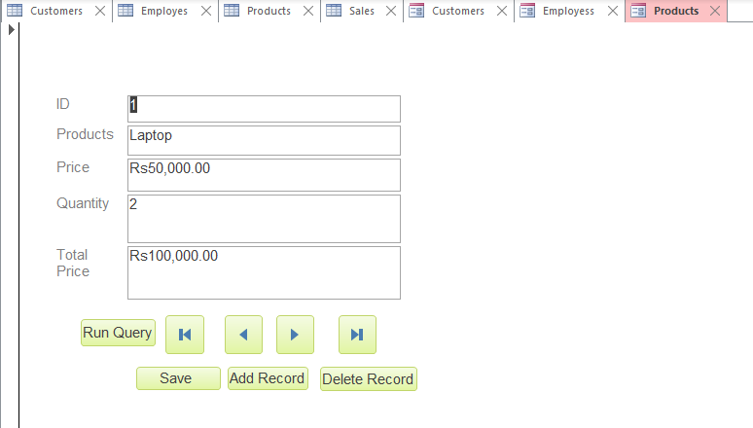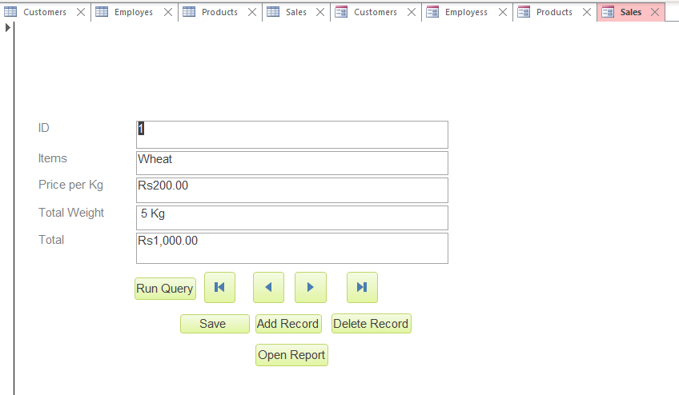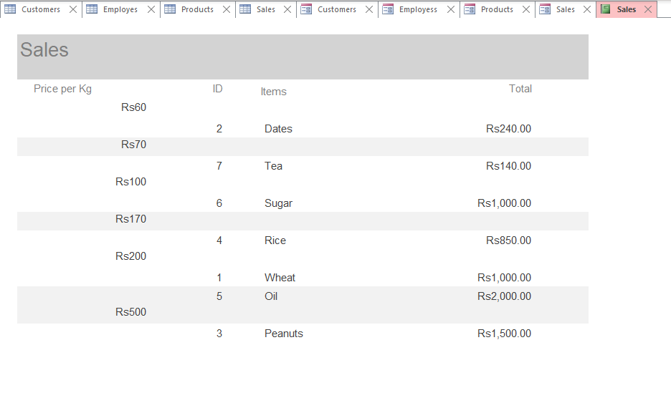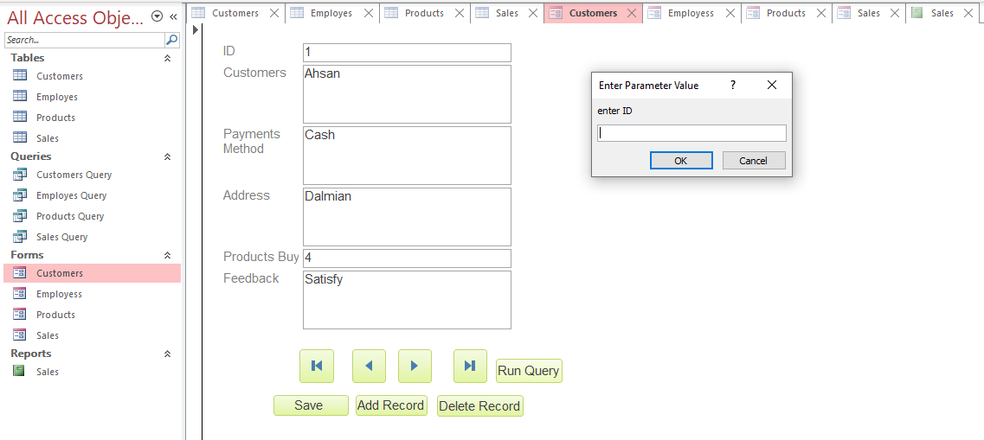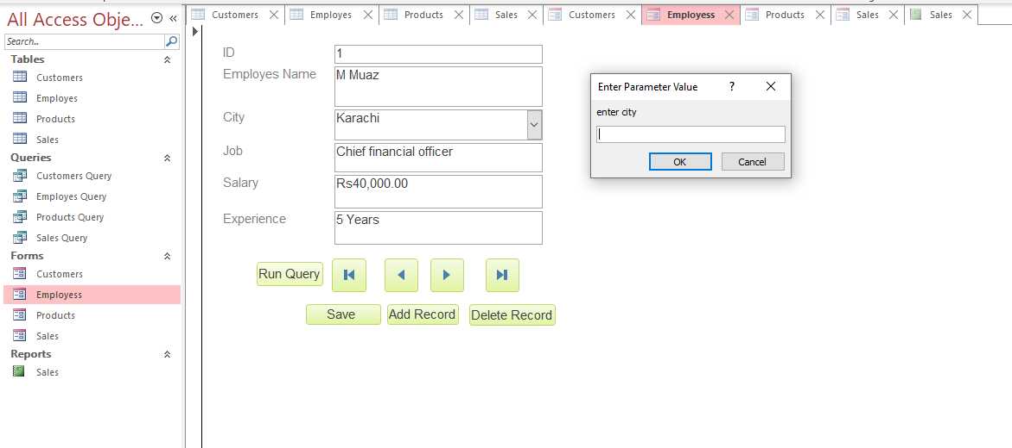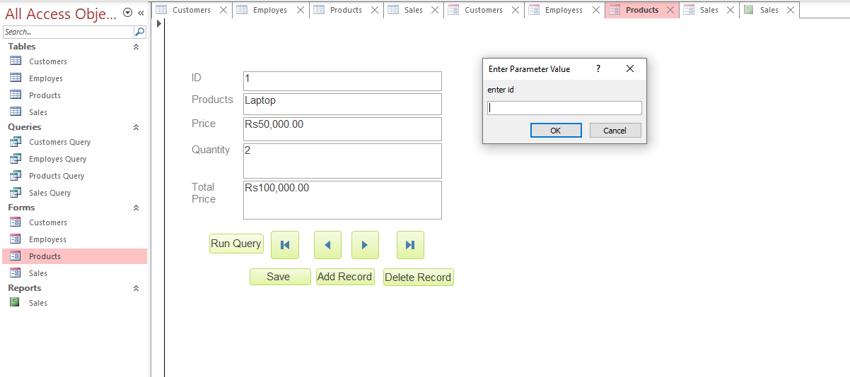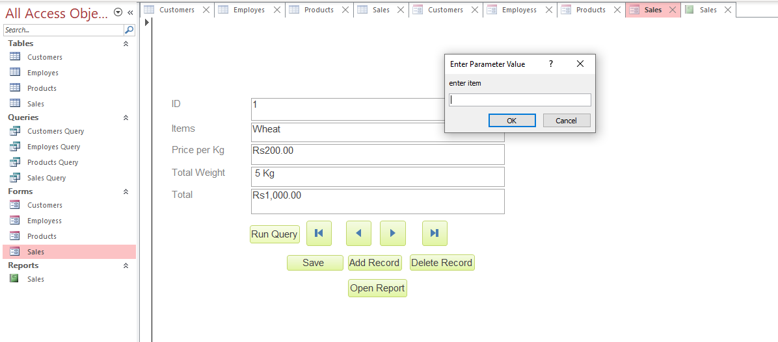

[data base task CF.accdb](data%20base%20task%20CF.accdb)